RESOLUTION NO.__________

RE: CERTIFICATE OF APPROPRIATENESS UNDER THE
PROVISIONS OF THE ACT OF THE PENNSYLVANIA
LEGISLATURE 1961, JUNE 13, P.L. 282 (53
SECTION 8004) AND BETHLEHEM ORDINANCE NO.
3952 AS AMENDED.

The applicant proposes to install a 5’ cedar fence with clear coat on the east and west side of the house at 241 E. Market St.

NOW, THEREFORE, BE IT RESOLVED by the Council of the City of Bethlehem that a Certificate of Appropriateness is hereby granted for the proposal.

Sponsored by: (s)

(s)

ADOPTED BY COUNCIL THIS DAY OF

(s)
President of Council

ATTEST:

(s)
City Clerk

HISTORICAL & ARCHITECTURAL REVIEW BOARD

The applicant proposes to install a 5’ cedar fence with clear coat on the east and west side of the house at 241 E. Market St.

APPLICATION #3:

Campbell Real Estate
130 W. 4th St.
Bethlehem, PA 18015

OWNER:

__________________________________________________________________________

The Board upon motion by Gen Marcon and seconded by Beth Starbuck adopted the proposal that City Council issue a Certificate of Appropriateness for the following:

- To install 5’ high cedar fencing to the east and west of the house.

2. The fence top will be “scalloped” with equal sized sections at each end.

3. The fence will be clear coated.

4. The motion was unanimously approved.

__________________________________________________________________________

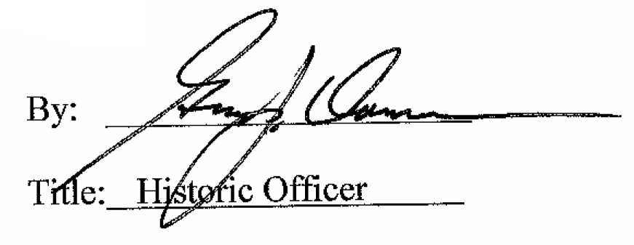

Date of Meeting: June 6, 2018

